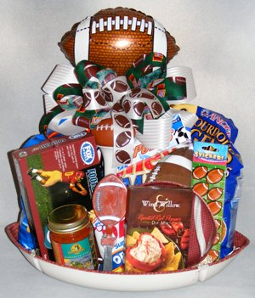
Dear ASU Prep Families,
The Sixth Grade students have selected the theme, “Sports” for their classroom basket that will be auctioned off at this year’s ASU Prep STEM Academy School Carnival. The carnival will be held on Friday, April 12th from 5-7pm. The PTSO and teachers are working hard to help make this year’s fundraiser a success! Proceeds from the auction will go towards enhancing your student’s education here at ASU Prep.
We need your help in collecting new items for the auction basket. We are asking for each family to donate a new item(s) that corresponds with the theme “Sports.” Please send in your donation with your student no later than Friday, March 29th. Feel free to contact Angie Obert at aobert@asu.edu with any questions or concerns. Go ASU Sun Devils!
Thank you for your support!
“Sports” Basket Ideas:
Gift Certificates (Dicks/Target/Walmart/Big 5)
Water Bottles
Top Golf Gift Card/Golf Course Gift Card
Football/ Soccer Ball/Basketball/Volleyball/Golf Balls & Tees
Sports Hat
Tickets to sporting events
Sports team apparel (ASU)
Sports snacks
Large Duffel Bag
Sport Umbrella
Blanket/Cooler/Lawn Chairs
**Please don’t forget the specials teachers! They are creating a Gift Card Basket!

